Oadby Granville Tennis Club
Code of conduct

All members of staff and volunteers agree to:
- Prioritise the well-being of all children and adults at risk at all times
- Treat all children and adults at risk fairly and with respect
- Be a positive role model. Act with integrity, even when no one is looking
- Help to cr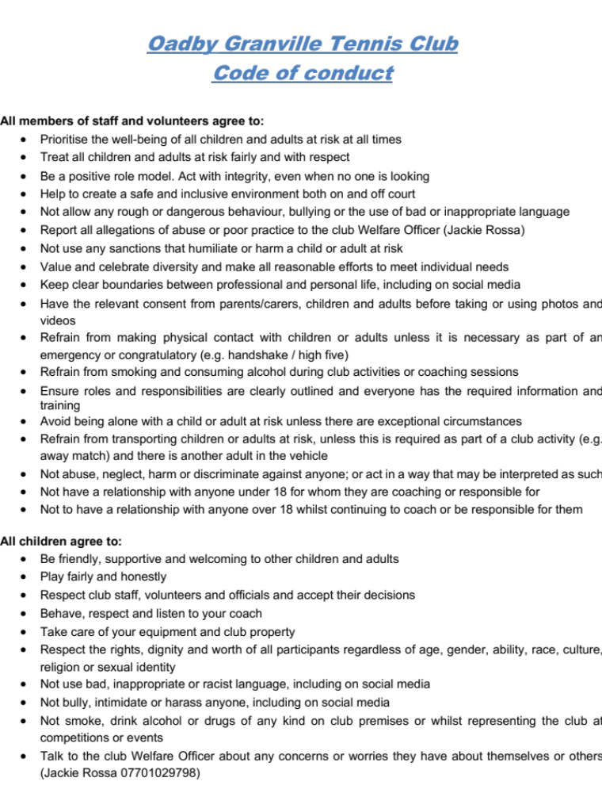eate a safe and inclusive environment both on and off court
- Not allow any rough or dangerous behaviour, bullying or the use of bad or inappropriate language
- Report all allegations of abuse or poor practice to the club Welfare Officer (Jackie Rossa)
- Not use any sanctions that humiliate or harm a child or adult at risk
- Value and celebrate diversity and make all reasonable efforts to meet individual needs
- Keep clear boundaries between professional and personal life, including on social media
- Have the relevant consent from parents/carers, children and adults before taking or using photos and videos
- Refrain from making physical contact with children or adults unless it is necessary as part of an emergency or congratulatory (e.g. handshake / high five)
- Refrain from smoking and consuming alcohol during club activities or coaching sessions
- Ensure roles and responsibilities are clearly outlined and everyone has the required information and training
- Avoid being alone with a child or adult at risk unless there are exceptional circumstances
- Refrain from transporting children or adults at risk, unless this is required as part of a club activity (e.g. away match) and there is another adult in the vehicle
- Not abuse, neglect, harm or discriminate against anyone; or act in a way that may be interpreted as such
- Not have a relationship with anyone under 18 for whom they are coaching or responsible for
- Not to have a relationship with anyone over 18 whilst continuing to coach or be responsible for them

All children agree to:
- Be friendly, supportive and welcoming to other children and adults
- Play fairly and honestly
- Respect club staff, volunteers and officials and accept their decisions
- Behave, respect and listen to your coach
- Take care of your equipment and club property
- Respect the rights, dignity and worth of all participants regardless of age, gender, ability, race, culture, religion or sexual identity
- Not use bad, inappropriate or racist language, including on social media
- Not bully, intimidate or harass anyone, including on social media
- Not smoke, drink alcohol or drugs of any kind on club premises or whilst representing the club at competitions or events
- Talk to the club Welfare Officer about any concerns or worries they have about themselves or others (Jackie Rossa 07701029798)

Associated policies and documents
- Reporting a concern form
- Safeguarding Policy
- Anti Bullying Policy
- Diversity and Inclusion Policy
- Code of Conduct
- Equity, Diversity & Inclusion Policy
- Staying safe online
- LTA Transgender and Non-binary Policy
- Photography and filming Policy
- Whistleblowing policy
- Guidance for senior team captains

